**Benchmark Software to Test & Evaluate Device Performance**

1. **PassMark Benchmarking software**

PassMark is a benchmarking software that performs several performance tests including prime numbers, integers, floating point, compression, physics, extended instructions, encoding, sorting. The higher the score is, the higher is the device capacity.

1. **Geekbench 5 Benchmark software**

* It find out how fast your Android device
* Geekbench 5 includes updated CPU tests that model real-world tasks and applications. These tests are designed to quickly and accurately measure mobile CPU performance. Every Geekbench 5 CPU test is multi-core aware, allowing Geekbench 5 to measure the full potential of your device's CPU.
* Geekbench 5 also includes new Vulkan Compute tests that measure the processing power of your device’s GPU.

**Geekbench 4 Benchmark software**

* Find out how fast your Android device
* Geekbench 4 makes benchmarks easy to run and to understand, and shows you how your device measures up to other systems on the market.
* Geekbench 4 includes updated CPU and GPU Compute tests that model real-world tasks and applications to measure performance.
* CPU tests are multi-core aware, evaluating your device’s performance with just a single core or at its full potential.

**Measure single core and multi core performance** and perform various operations, including:

* AES-XTS
* Text Compression
* Image Compression
* Navigation
* HTML5
* SQLite
* PDF Rendering
* Text Rendering
* Clang-Camera
* N-Body Physics
* Rigid Body Physics
* Gaussian Blur
* Face Detection
* Horizontal Detection
* Image In-Painting
* HDR
* Ray Tracing
* Structure From Motion
* Speech Recognition
* Machine Learning

1. **AnTuTu Benchmark software**

AnTuTu is one of the most popular apps in the world to evaluate and compare the power of a mobile device with the competition. It tests above all the power of calculation, the display of Web pages, the modeling of decorations in 3D, the management of the memory, the transfer of data.

Antutu will comprehensively test all aspects of a device, including UX, GPU, RAM, CPU, I/O and more. Each item is individually assessed and given a score. These scores can be uploaded to the Antutu database, and then used to rank your device among all other Android devices.

**New features in Antutu V8.0:**

1. **CPU:** Upgraded test algorithms, optimized support for ARM's new Tri-Cluster architecture, and adjusted the stress distribution.
2. **GPU:** Introduces new Vulkan scene "Terracotta Warriors" to test the GPU performance of the mobile phone when running high-stress games natively developed using Vulkan technology.
3. **GPU:** Upgrades "Coastline" scene from OpenGL ES 3.1 to Vulkan to test the Vulkan gaming performance of GPU under medium-to-high stress.
4. **MEM:** Fully upgraded Memory test items, to test both hardware Direct I/O and system filesystem performance.
5. **UX:** Increases the load of all the test scenes. Screen refresh rate is included into the scope of measurement.
6. **3Dmark Wild Life Benchmark software**

It tests vulkan performance of the GPU. Use 3DMark Wild Life to test and compare the graphics performance of notebook computers, tablets and smartphones. Wild Life uses the Vulkan graphics API on Windows PCs and Android devices.

Link: <https://benchmarks.ul.com/compare/best-gpus>

* 3DMark benchmarks the GPU and CPU performance of your device
* At the end of the test, you get a score, which you can use to compare models
* 3DMark is designed around data-driven stories that help you learn more about your smartphone and tablet.
* With its unique charts, lists and rankings, 3DMark gives you unrivaled insights into the performance of your device.
* Compare your score with others from the same model.  
  • Compare your device’s performance with other popular models.  
  • See how your device’s performance changes with each OS update.  
  • Discover the devices that perform consistently without slowing down.  
  • Search, filter and sort our lists to compare the latest mobile devices.
* 3DMark Wild Life offers two ways to test your device: a quick benchmark that tests instant performance and a longer stress test that shows how your device performs under longer periods of heavy load.
* **3DMark Wild Life Extreme** is a new test that sets a high bar for the next generation of Android devices. Don’t be surprised by low frame rates as this test is too heavy for many current phones and tablets.

**System requirements**  
• Wild Life benchmarks require Android 10 or above and 3 GB or more of RAM.  
• All other benchmarks require Android 5 or above.

1. **AIDA64 Benchmark software**

AIDA64 implements a set of 64-bit benchmarks to measure how fast the computer performs various data processing tasks and mathematical calculations. Measures CPU performance using AES (Advanced Encryption Standard) data encryption. It display detailed information of the computer components.

* CPU detection, real-time core clock measurement
* Screen dimensions, pixel density and camera information
* Battery level and temperature monitoring
* WiFi and cellular network information
* Android OS and Dalvik properties
* SoC and device model identification
* Memory and storage utilization
* OpenGL ES GPU details, real-time GPU clock measurement
* Vulkan, OpenCL, CUDA, PCI, USB device listing
* Sensor polling
* Listing of installed apps, codecs and system directories
* Android Wear module: native app for watches
* System requirements: Android 4.2 or later

**Testing ROC-RK3588S-PC**

**Results on different benchmarks:**

1. **Geekbench 5 & Geekbench 4**
2. **3Dmark Wild Life** (It tests vulkan performance of the GPU)
3. **AnTutu** (It tests many parts of your device and assigns an overall score)

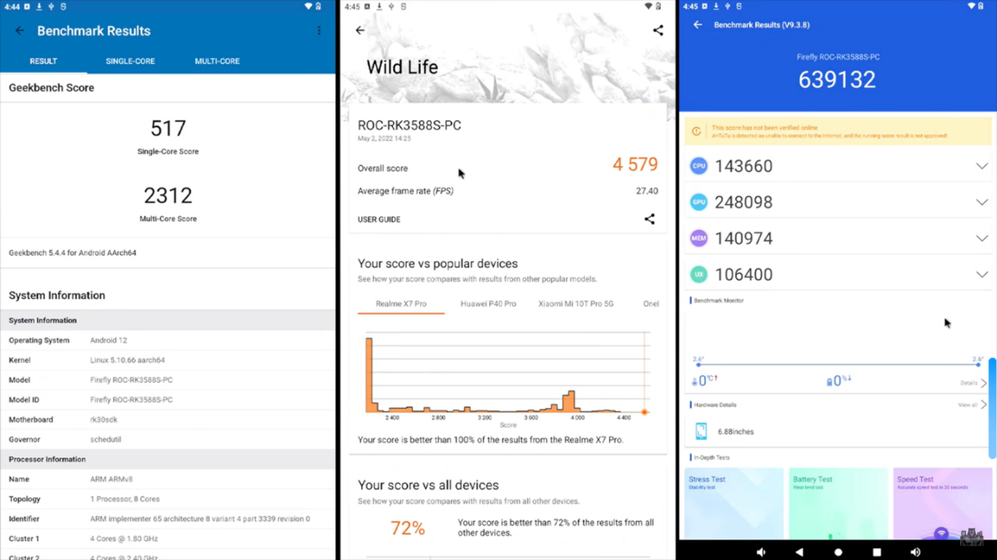

**Running Emulators:**

1. **Dreamcast Redream, Link:** [**https://redream.io/**](https://redream.io/)
2. **PPSSPP (PSP Emulator) Vulkan 5X Res, Link:** [**https://www.ppsspp.org/**](https://www.ppsspp.org/)
3. **GC Dolphic Vulkan, Link:** [**https://dolphin-emu.org/blog/tags/vulkan/**](https://dolphin-emu.org/blog/tags/vulkan/)
4. **PS2 AestherSX2 PS2 Emulator, Link:** [**https://www.youtube.com/watch?v=57X2MqIVMNg**](https://www.youtube.com/watch?v=57X2MqIVMNg)

**Emulator Results**

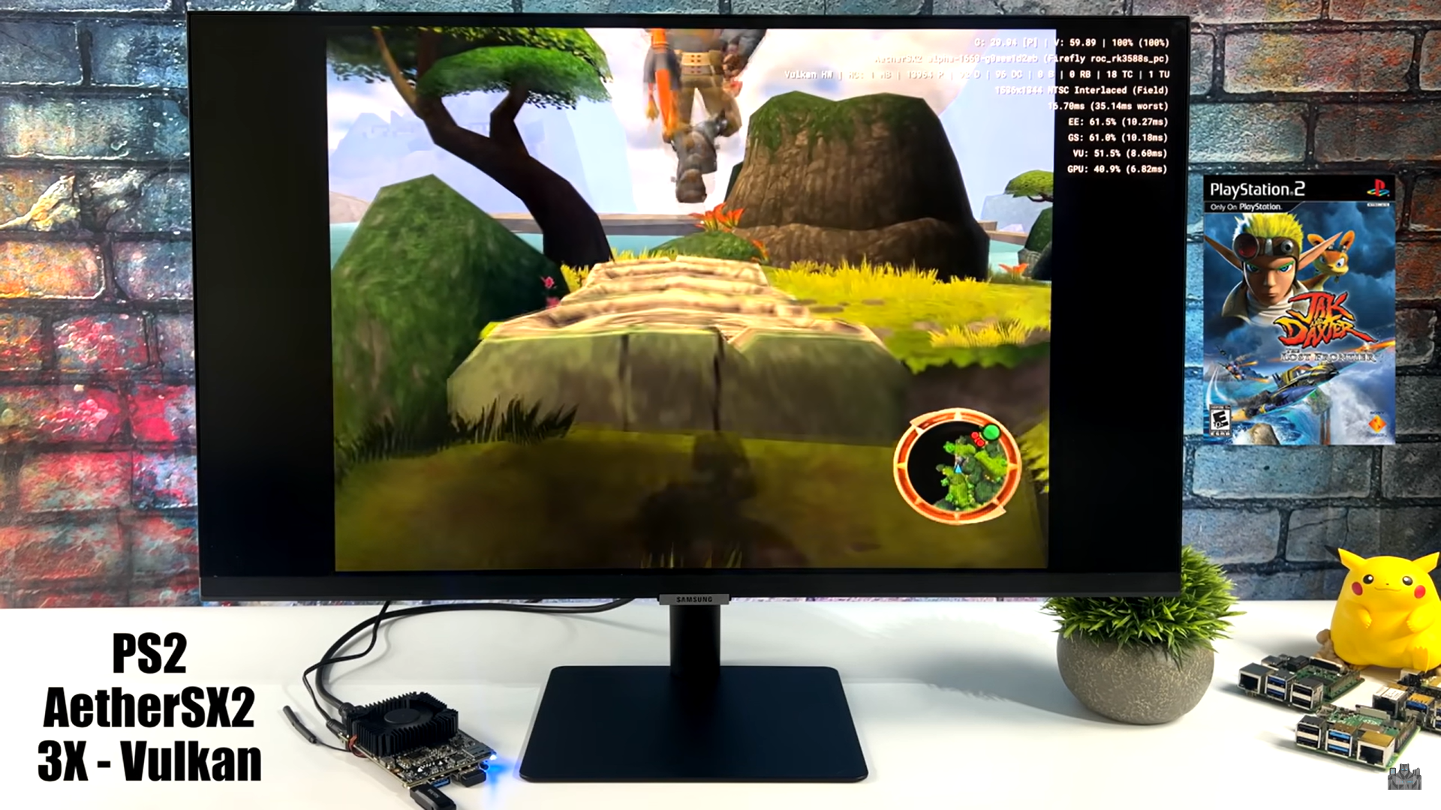

**AIDA64: It display detailed information of the computer components**

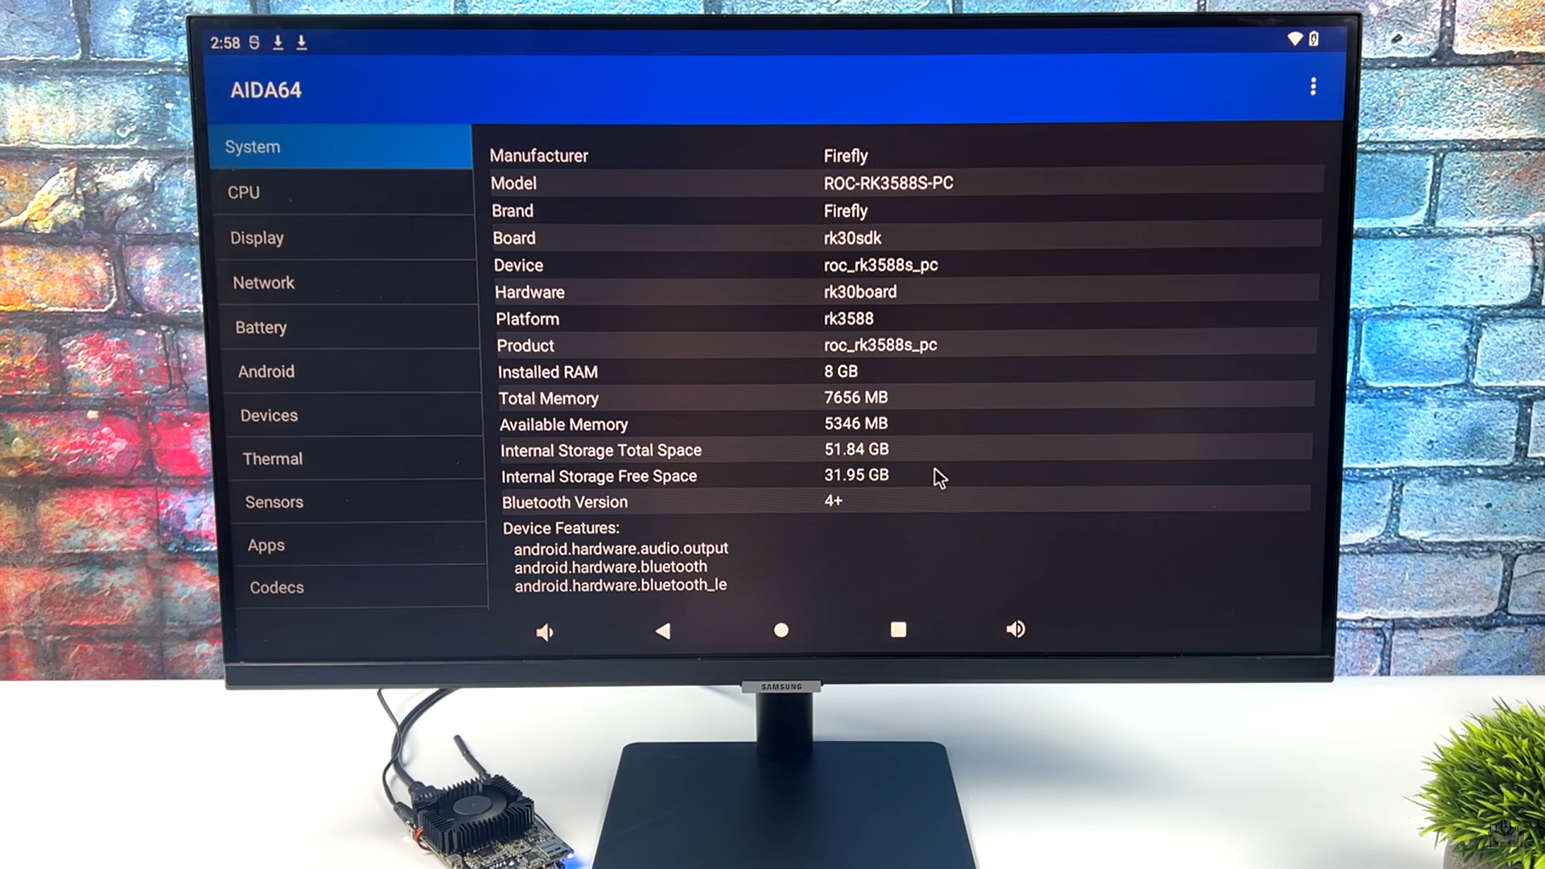

**Rockchip RK3399pro Benchmark Test Performance**

**Testing Date:** August 19th 2022, 3:57pm

**System Information**

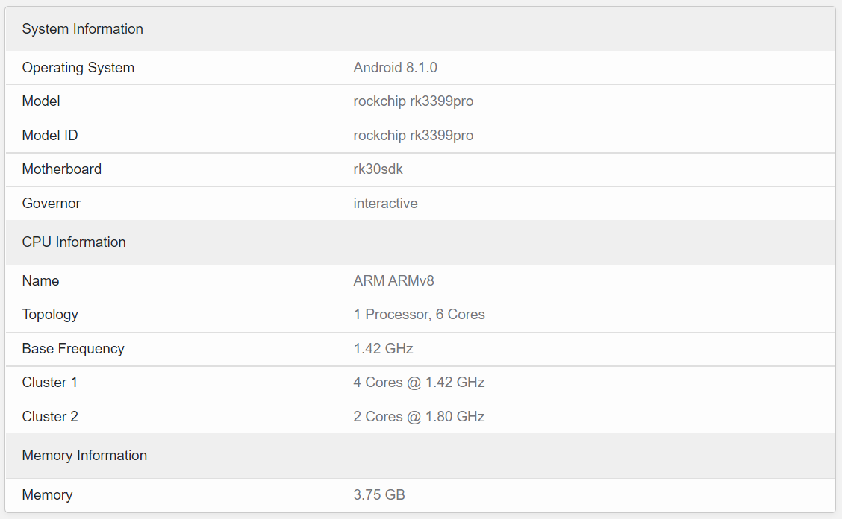

**CPU Benchmark**

CPU benchmark measures the **performance of CPUs** at performing everyday tasks using tests designed to simulate real-world applications.

**Rockchip RK3399pro CPUs benchmark:**

**Geekbench 5 Score**



**Geekbench 5.4.4 for Android AArch64**

**Single-Core Performance**

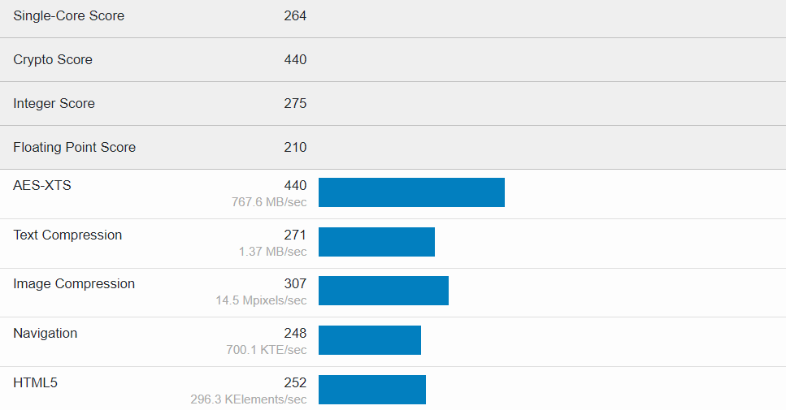

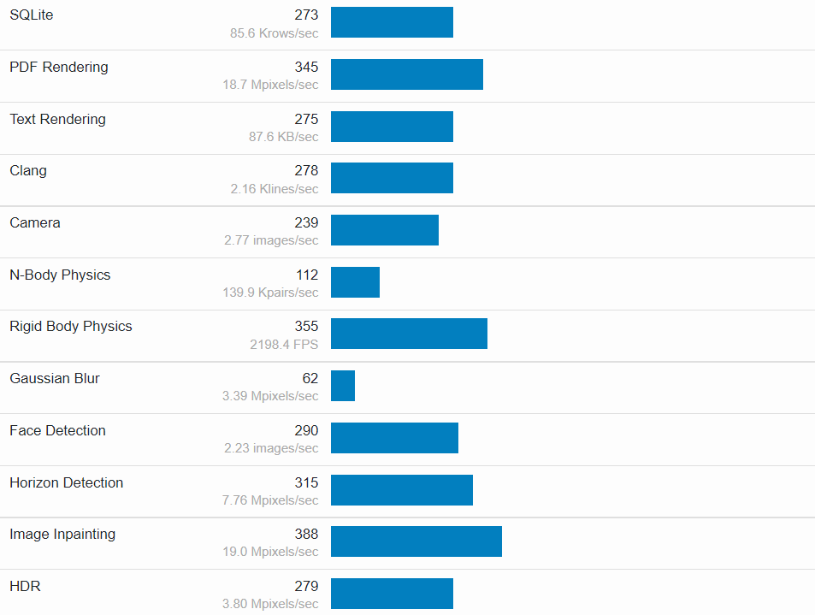

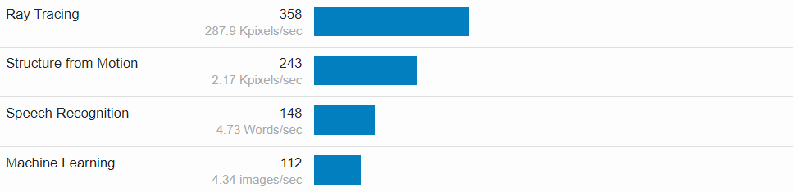

**Multi-Core Performance**

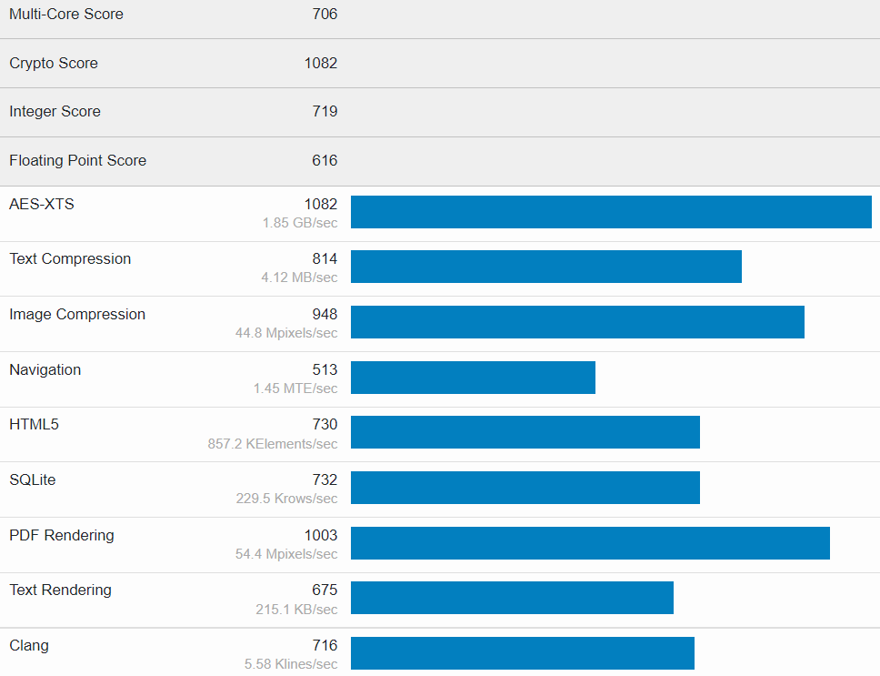

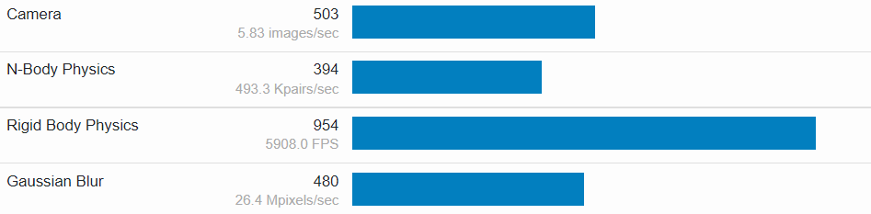

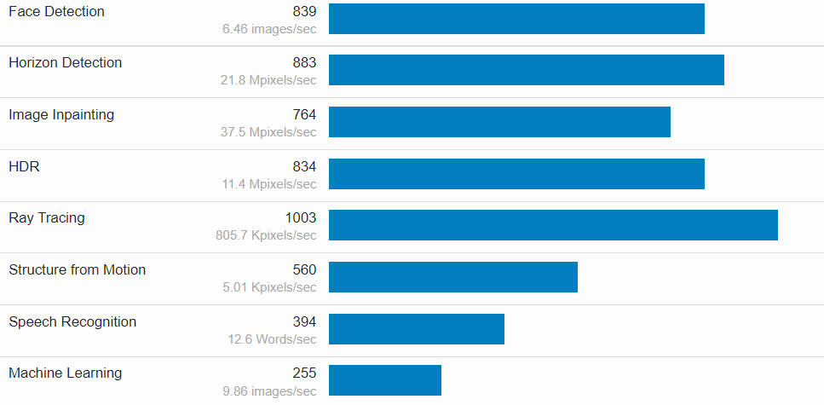

**Compute Benchmark**

Compute benchmark measures the **performance of GPUs** at performing common compute tasks (e.g., Image processing). Compute API is **OpenCL.**

It perform various operations, including:

* Running sobel
* Canny
* Stereo matching
* Histogram equalizer
* Gaussian blur
* Depth of field
* Face detection
* Horizon detection
* Feature matching
* Particle physics
* SFFT

**Rockchip RK3399pro 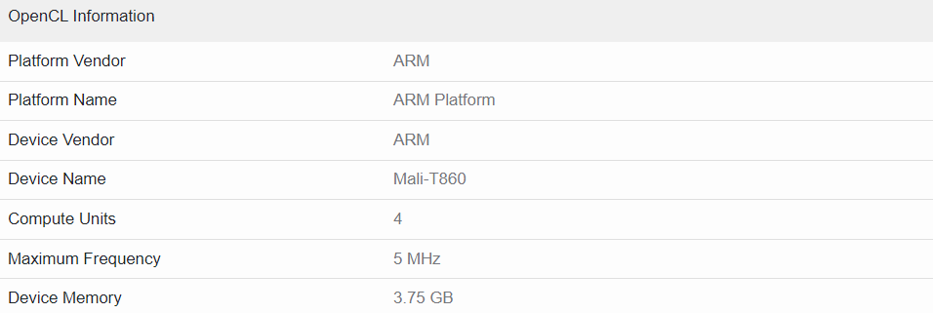 OpenCL information**

**Rockchip RK3399pro GPUs benchmark: Geekbench 5 Score**

**OpenCL Performance:**

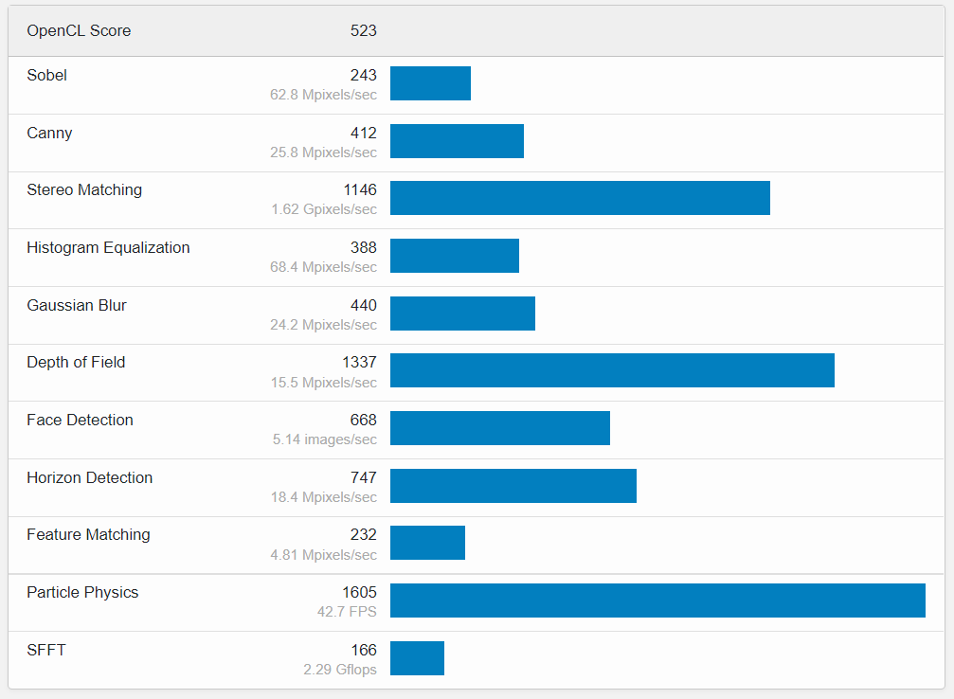

**Compute Comparison**

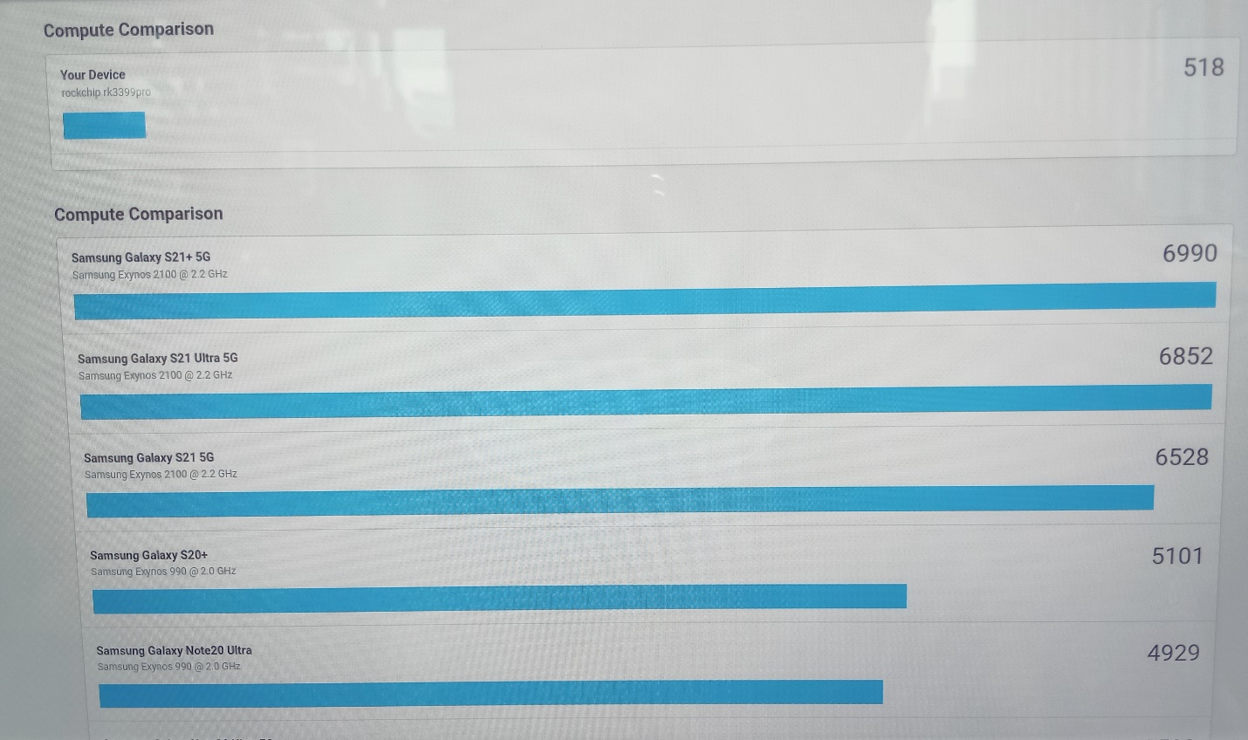

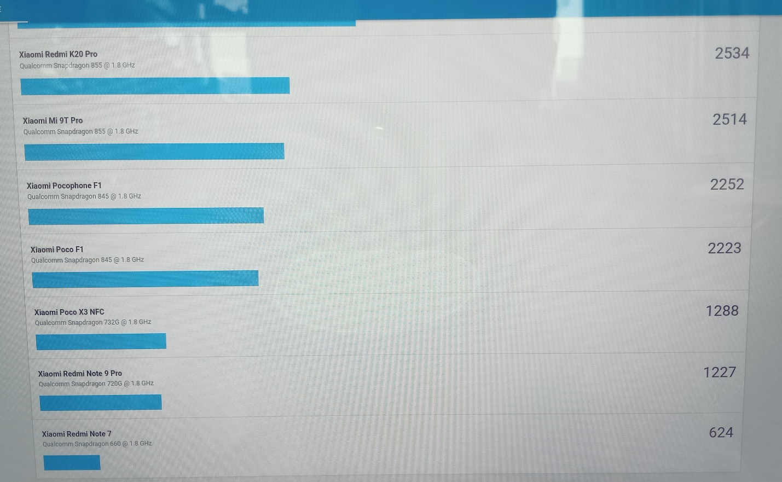

**Rockchip RK3399pro CPUs benchmark: Geekbench 4 Score**

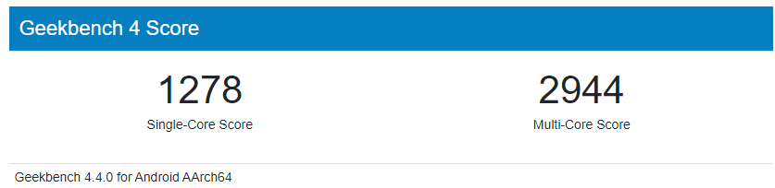

**Single Core Results Performance**

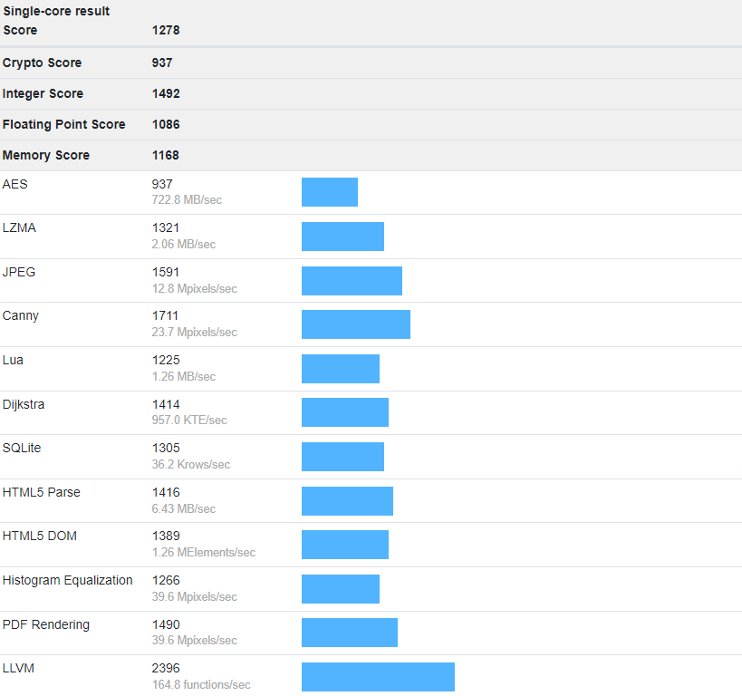

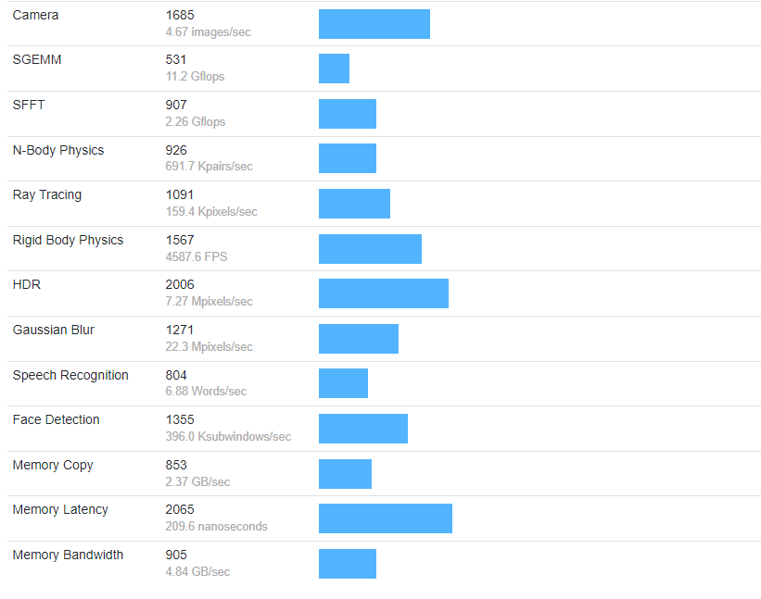

**Multicore Results Performance**

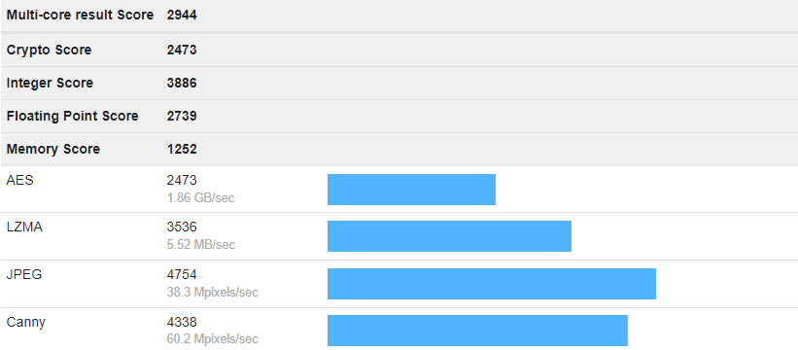

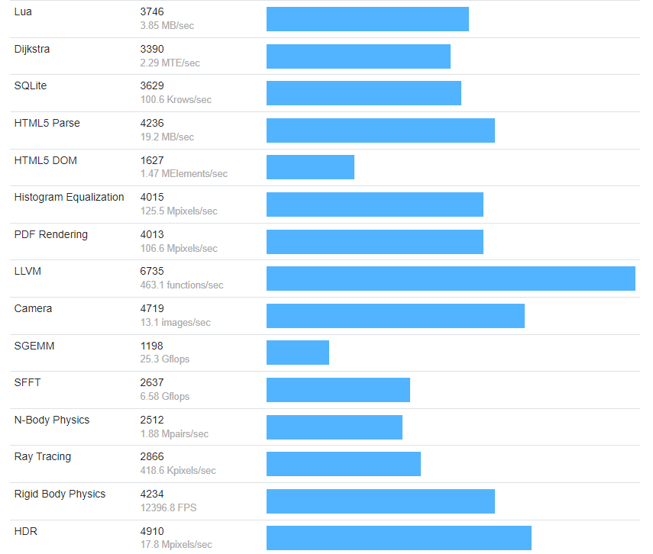

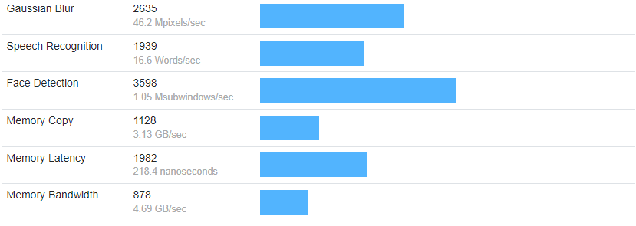

**3DMark Benchmark Software**

1. Sling Shot: Choose Sling Shot or Sling Shot Extreme benchmarks to compare low- to mid-range Android devices with older iPhone and iPad models.

**Overall score** 1096

**Graphic card score (Measure GPU Performance)** 1011

Graphic card test 1 (FPS) 6.40

Graphic card test 2 (FPS) 3.30

**Physical Test Score (Measure CPU Performance)** 1549

Test 1 (FPS) 30.30

Test 2 (FPS) 16.6

Test 3 (FPS) 8.3

Score is 33% better than that of other devices.

**Performance Monitoring**

During the test run equipment operation status:

CPU clock (GHz) 0.4 GHz to 1.5 GHz

Power / Battery 100% to 100%

Temperature 42% to 42 %

Frame Rate (FPS) 2 FPS to 38 FPS

1. **Sling Shot Unlimited**

**Overall score** 1132

**Graphic card score (Measure GPU Performance)** 1053

Graphic card test 1 (FPS) 7.20

Graphic card test 2 (FPS) 3.30

**Physical Test Score (Measure CPU Performance)** 1533

Test 1 (FPS) 32.70

Test 2 (FPS) 16.00

Test 3 (FPS) 8.1

Score is 15% better than that of other devices.

**Performance Monitoring**

During the test run equipment operation status:

CPU clock (GHz) 0.4 GHz to 1.5 GHz

Power / Battery 100% to 100%

Temperature 42% to 42 %

Frame Rate (FPS) 2 FPS to 31 FPS

**Other Tests:**

* **Wild Life Extreme:** It is a new test that sets a high bar for the next generation of Android devices. Don’t be surprised by low frame rates as this test is too heavy for many current phones and tablets.
* **Wild Life:** a quick benchmark that tests instant performance
* **Wild Life stress test:** It shows how your device performs under longer periods of heavy load

RK3399 is not compatible for above tests. It required android 10 or above version.

**AnTuTu Benchmark Software**

Overall Score 137542

CPU 44590

GPU 22909

Memory 24172

UX 45871

**CPU Score:**

CPU arithmetic operation 14980

CPU common algorithm 8951

CPU multicore performance 20659

**GPU Score:**

GPU isolation--OpenGL ES3.0 12132

GPU coastline--OpenGL ES3.0 10777

**Memory Score:**

Read / Write 14271

Application storage speed 2478

Sequential read speed 4023

Sequential write speed 1596

Random read and write 1804

**UX Score:**

Data security 11235

Data processing 7761

Image processing 4392

List, HTML, QR 12229

Video compatibility 7000

Video decoding performance 3254

**AIDA64 Benchmark software**

**Initial temperature before testing operations**

SoC temperature 50.6 C

GPU temperature 51.1 C

**After testing operations temperature**

SoC temperature 74.3 C

GPU temperature 69.4 C

**AiSDKDemo (Two cameras)**

Temperature before running AiSDKDemo

SoC temperature 52.1 C

GPU temperature 52.3 C

Temperature after running AiSDKDemo for 15 mints

SoC temperature 70.4 C

GPU temperature 69.3 C

**ITX-3588J 8K AI Benchmark Test**

1. **Geekbench 5 Benchmark Software**

Single core score 506

Multicore score 2319

1. **3D Wild Life Benchmark Software**

Overall score 4523

Average frame rate (FPS) 27.10

1. **AnTuTu Benchmark Software**

Overall Score 648087

CPU Score 142937

GPU Score 247695

Memory Score 140954

UX Score 116501

What is benchmark performance test?

In computing, a benchmark is the act of running a computer program, a set of programs, or other operations, in order to assess the relative performance of an object, normally by running a number of standard tests and trials against it.